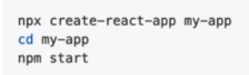

Delete these files first, and clean the index.js file.

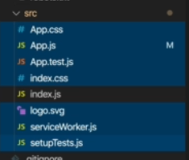

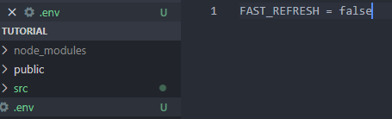

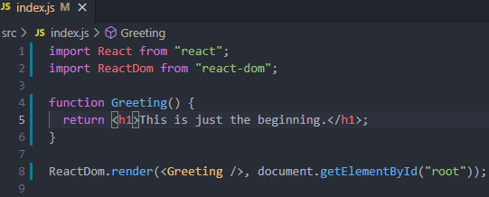

## React Components

Components are independent and reusable bits of code. They serve the same purpose as JavaScript functions, but work in isolation and return HTML.

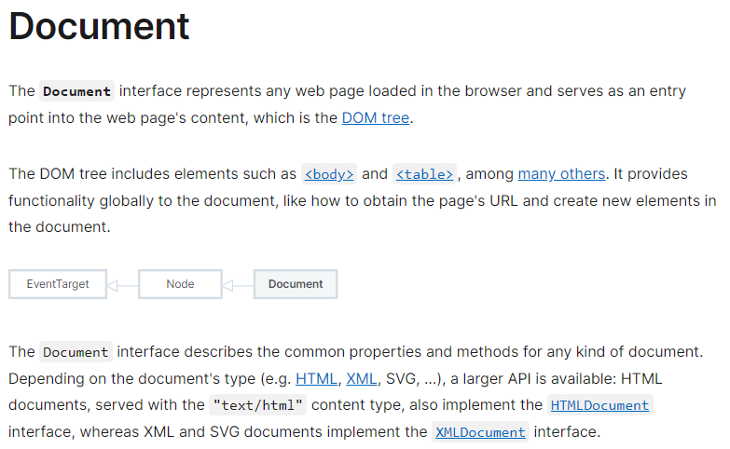

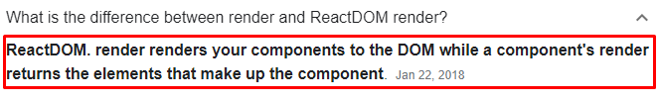

-> Here, getElementById('root') MEANS: ***Render the whole React App into the element with id=root*** *.*

**First Component in Detail:**

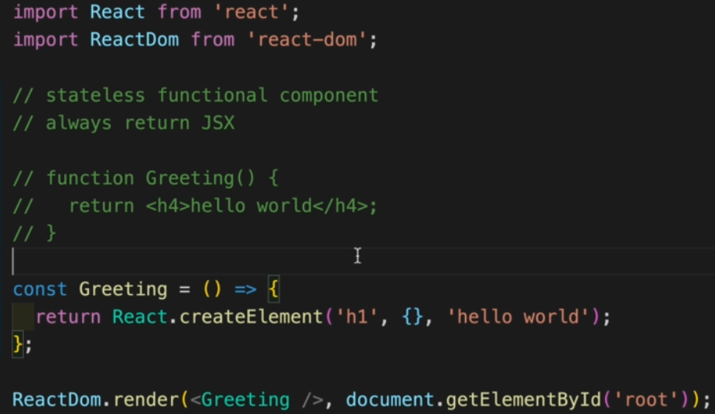

Now, Write it in a simple way,

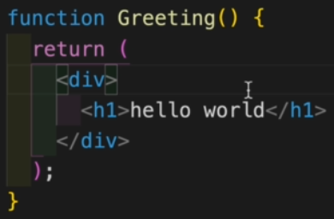

Instead of this,

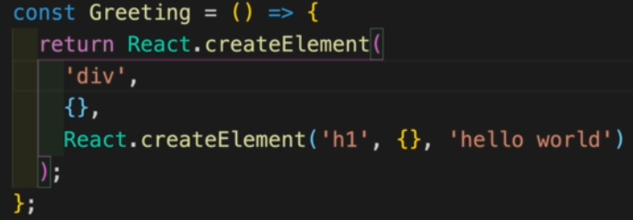

**JSX Rules:**

JSX stands for **JavaScript XML**. JSX allows us to write HTML in React. JSX makes it easier to write and add HTML in React.

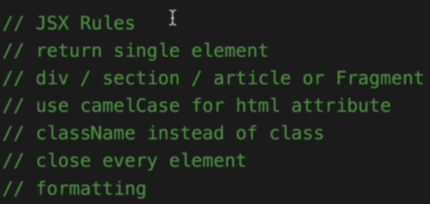

Return Single Element means the whole thing will be wrapped into a div.

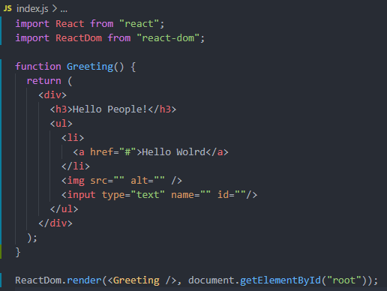

**Nested Components and Tools**

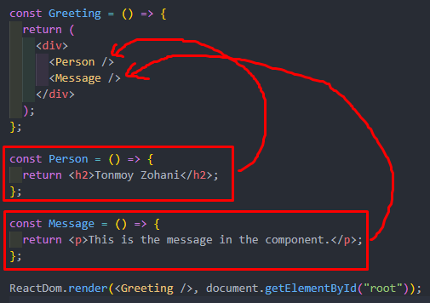

We can create separate components and set those into the main component.

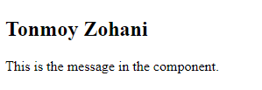

**Mini Book Project**

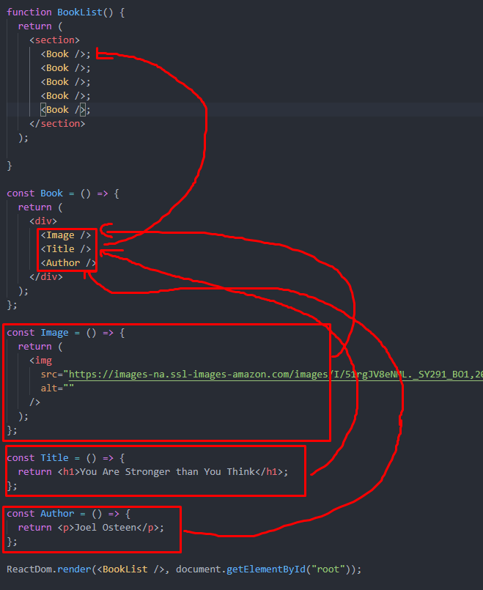

Here, We create three components name Image, Title, and Author. And pack those three components into a component name Book. That Book component will be sent to another component in the BookList.



**CSS:**

Create a CSS file.

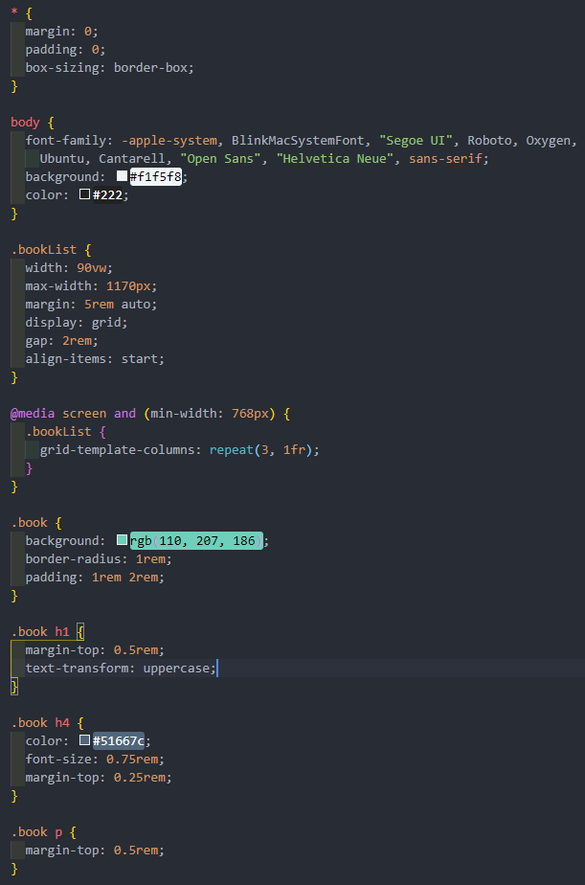

Now, Import that CSS file,



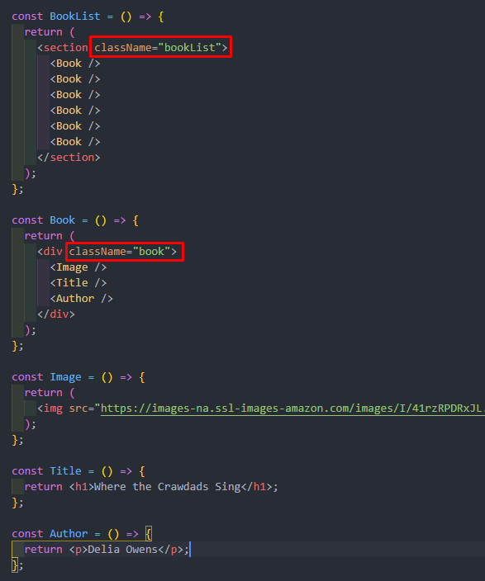

Here, CSS style will be applied to Book. And in the Book component, there are three components. So, the CSS style of Book component will be also applied to those three components.

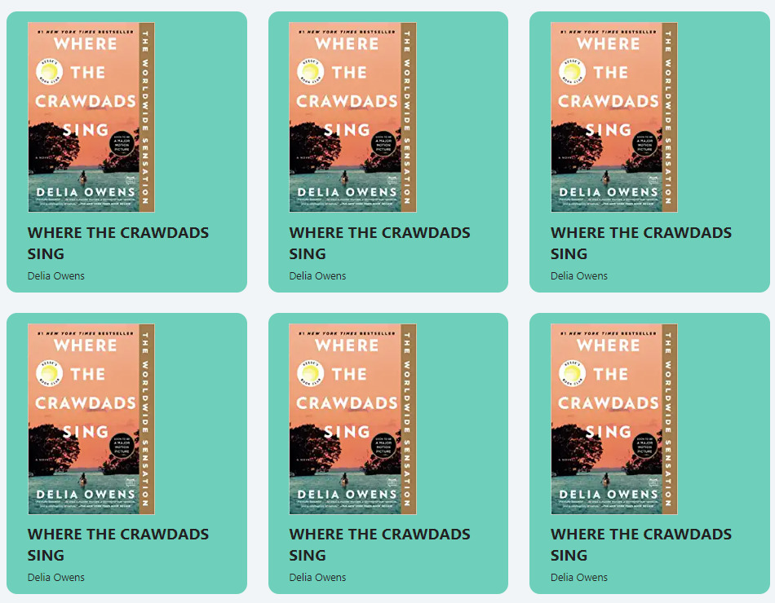

**JSX - CSS**

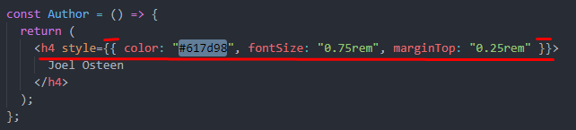

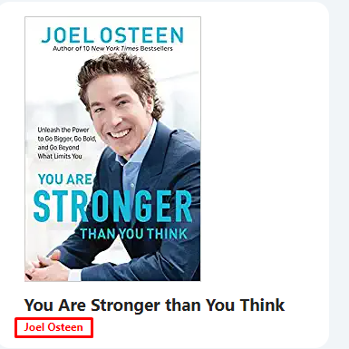

**JSX - Javascript**

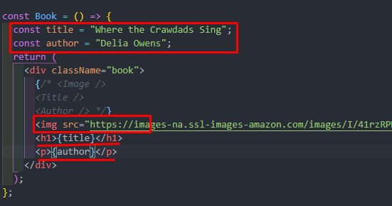

Now, we have removed three components and into the Book component, we set property manually. Here, we have used JavaScript.

**Props**

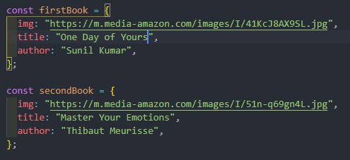

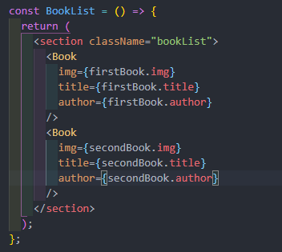

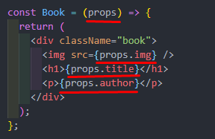



React allows us to pass information to a Component using something called props (**stands for properties**). Props are basically kind of global variable or object.

We use props in React **to pass data from one component to another** (from a parent component to a child component(s)). Props are just a shorter way of saying properties. They are useful when you want the flow of data in your app to be dynamic.

**Props - Destructuring**

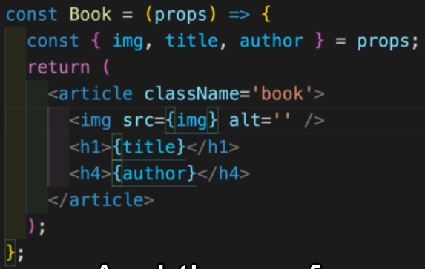

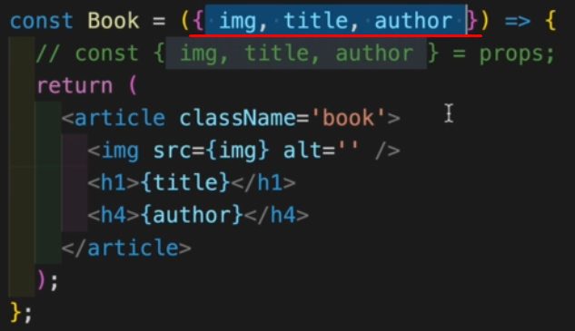

**Props - Children**

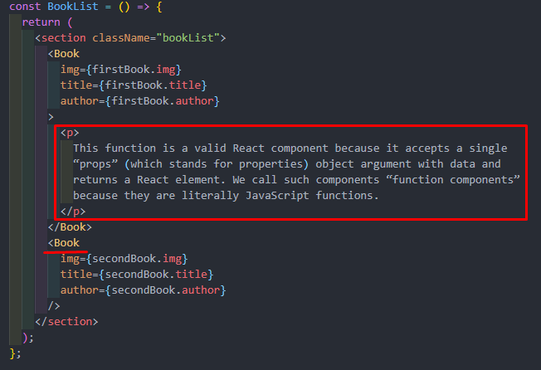

Children should be written between the same Components.

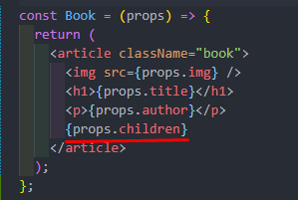

The children of props are declared in this way.

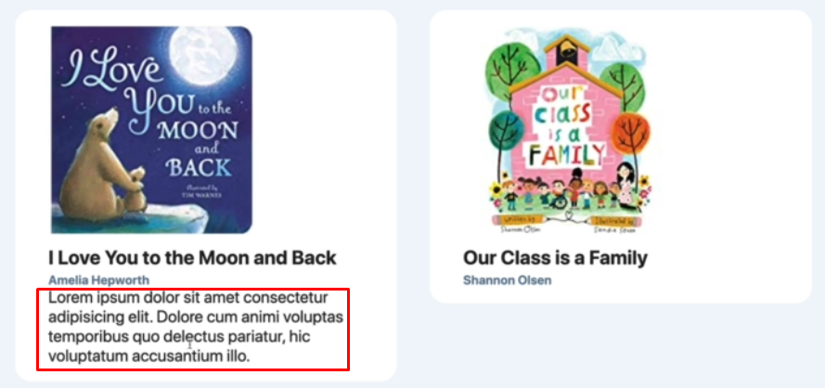

**Simple List:**

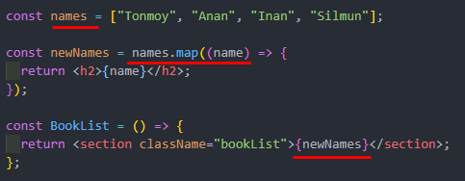



Here, We have used the map method to print one-by-one elements.

**Proper List**

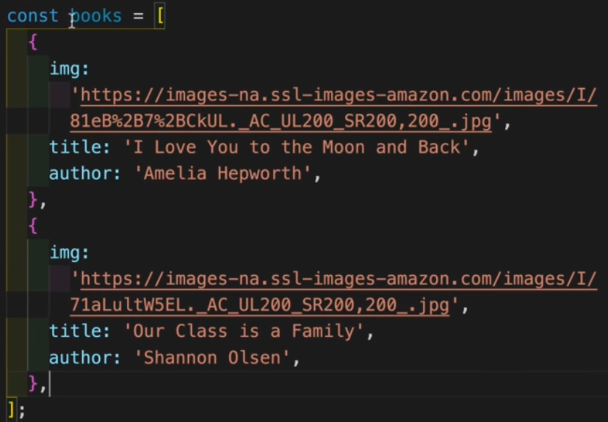

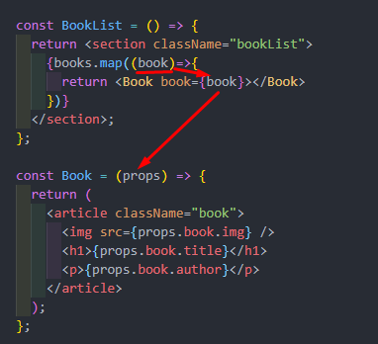

What happened here,

1. One book is tracked by the map method.
2. book is an object and it has three properties.
3. Now, It is needed to pass the book. But how?
4. As it is an object, so it has been passed as an object named “***book***”
5. The passing book is received by the props.
6. Now to print, we have used ***props.book.property*** . As it is an object.

*Alternative style. ( Destructuring)*

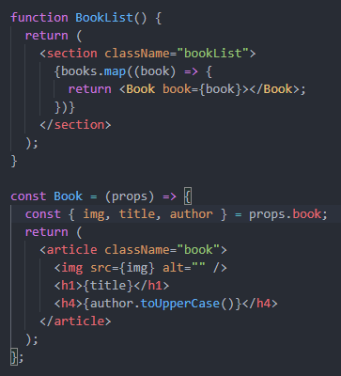

**Key Prop and Spread Operator**

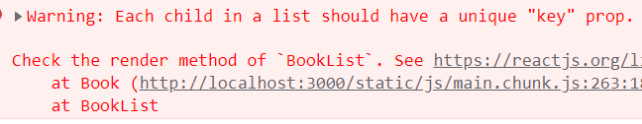

Here, We got a warning where it indicated that we needed a unique key to every property. So,We set key to every property.

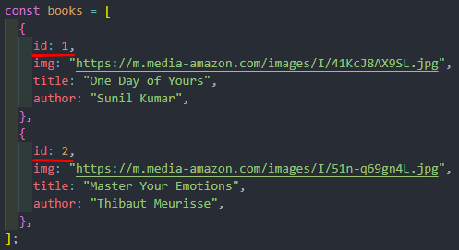

Now, this key will be passed through the Book component.

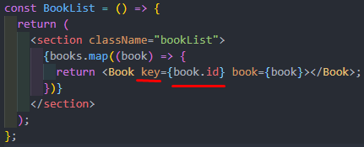



No warning now.

*Alternative style ( By Spreading Operator )*

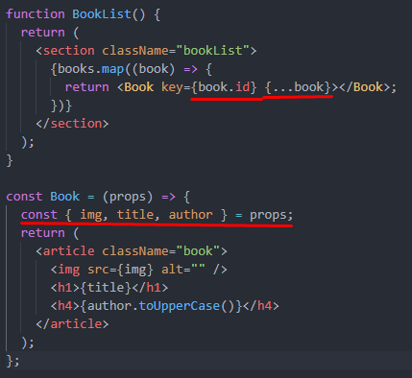

**Event Basics:**

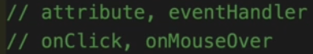

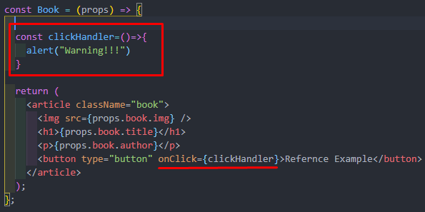

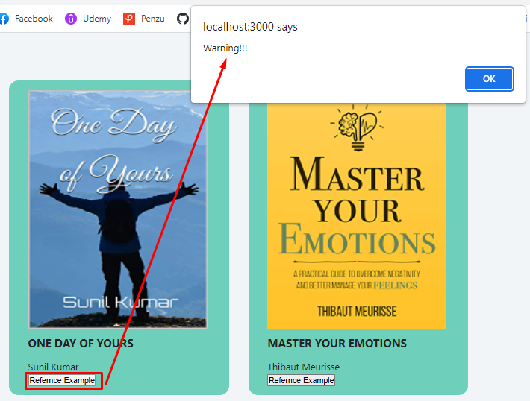

*Complete Code*

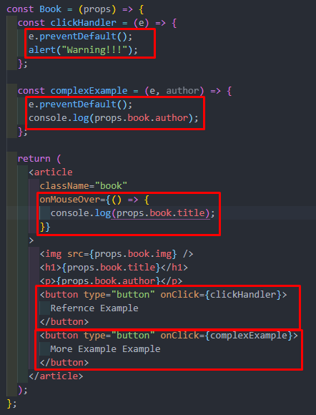

*Smilga’s code*

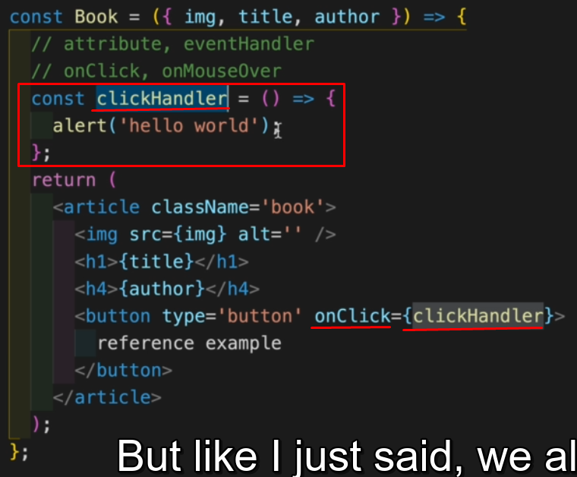

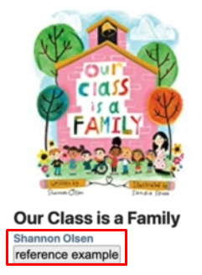

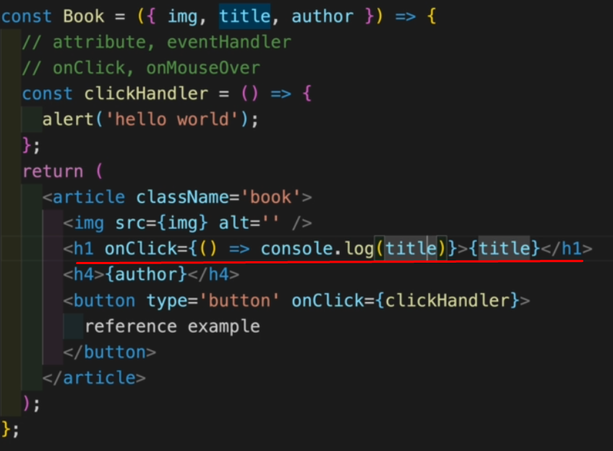

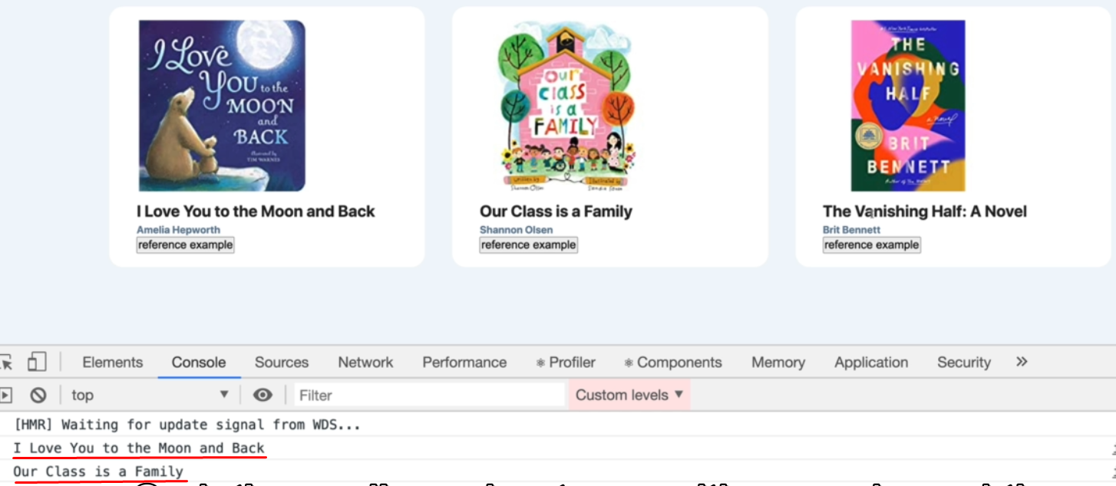

***The Tricky part is here***

